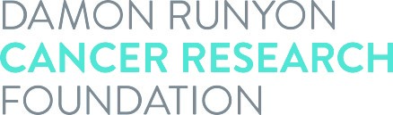

**Acceptance of Award**

I realize that the Damon Runyon Scholars Program for Advancing Research and Knowledge Award is given to a limited number of individuals and accept this award with a good-faith intention of completing the full award term. It is understood by all parties that this award in no way constitutes an employer-employee relationship between the Damon Runyon Cancer Research Foundation and the recipient. I hereby certify that upon acceptance of the award, I will not hold another position during the program appointment and will commit to full-time research. Additionally, I will abide by the rules and regulations set forth by the host institution. I will identify myself as a Damon Runyon SPARK Scholar and consent to the use of my name, photograph, and description of discoveries related to this award as well as subsequent scientific achievements in connection with Damon Runyon's solicitations and publicity of its activities. All the following parties agree to abide by the terms set forth in the Award Statement.

**Damon Runyon Award recipient's signature:** ____________________________ **Date:** ___________________

**Print Awardee’s name:**

**Lab Mentor's signature:** ______________________________________________ **Date:** ___________________

**Institutional signature:** _____________________________________________ **Date:** ___________________

**Print Institutional Signee’s name:**       **Title:**